Contents

**No table of contents entries found.**

##### ELECTROMAGNET

* It develops a magnetic field between the U-shaped design (electromagnets).

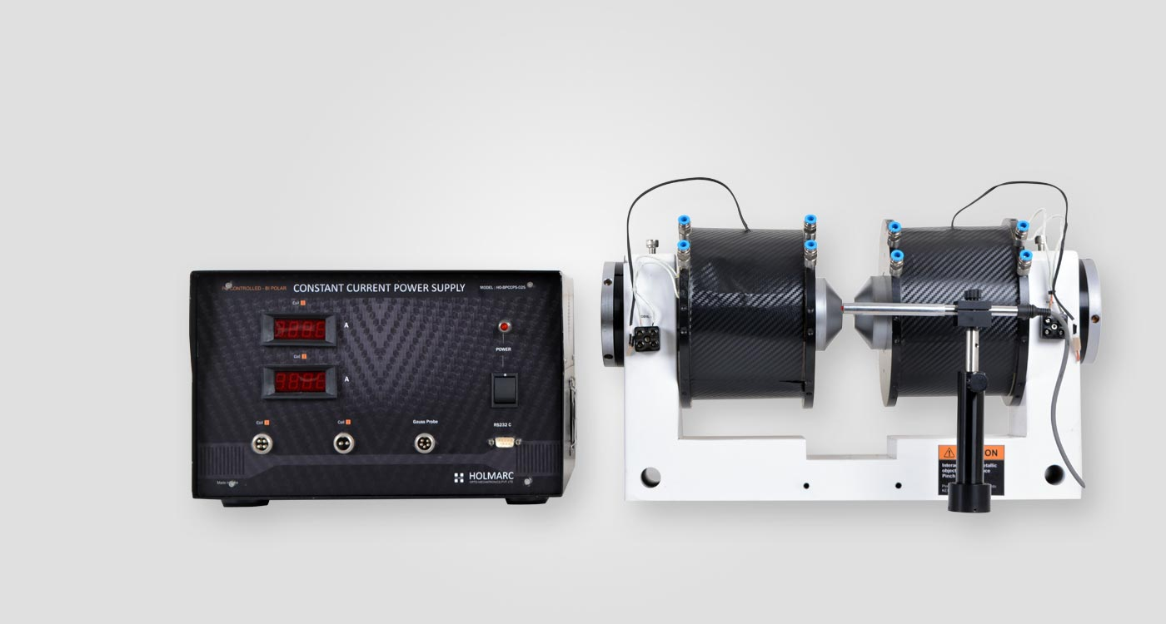

Gauss probe

U shaped design

Pole jaw

Top screws

Figure 1 Electromagnet with CCPS

Constant current power supply(CCPS)

Main switch of CCPS

##### TURN ON PROCEDURE

* Turn on the chiller main
* Turn on the chiller pump
* Turn on constant current source
* Plug on the RS-232 cable to LAB PC
* Open the EM controller software in LAB PC

##### TEMPERATURE SETUP IN CHILLER

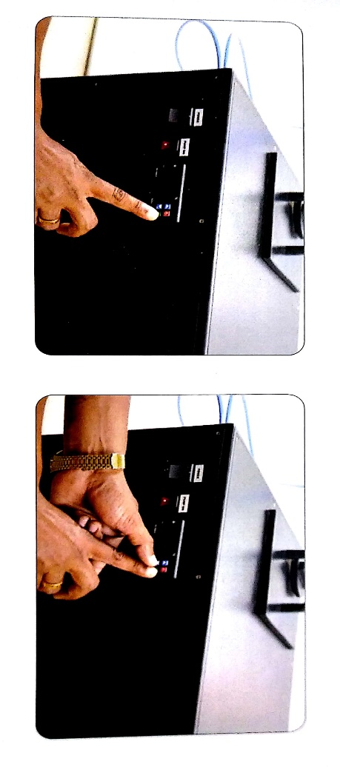

Chiller pump

Chiller main

Figure 2 Chiller

* It works on auto setting
* For manual setting, double click the set button, then use up and down arrow to level the temperature as shown in fig 2

##### TEMPERATURE SETUP IN CCPS:

* To change the threshold temperature (over which the CCPS will cut off), hold the set button (the square button), holding the set button, press up or down arrow to increase or decrease the temperature respectively.

##### CALIBRATION OF ELECTROMAGNETS

* Change the pole distance by adjusting top screws with help of L/T screw, then pole jaw with the help of screw as shown in fig 3

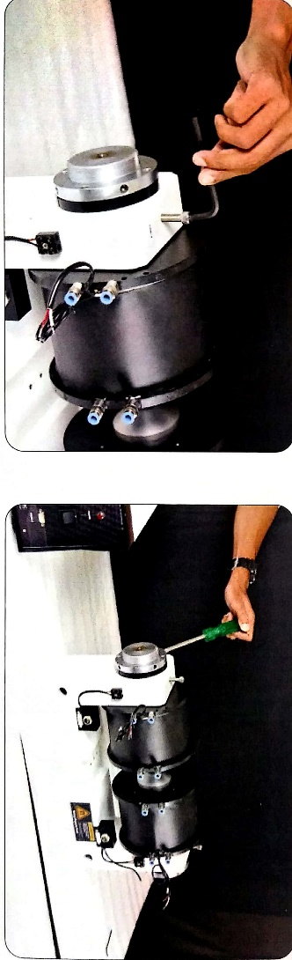

Figure 3 Adjusting the pole gap

* Tight the top screw after adjusting the pole gap
* Place the gauss probe(Hall probe) is exactly middle between electromagnets
* 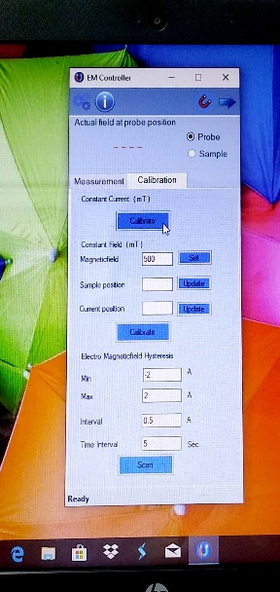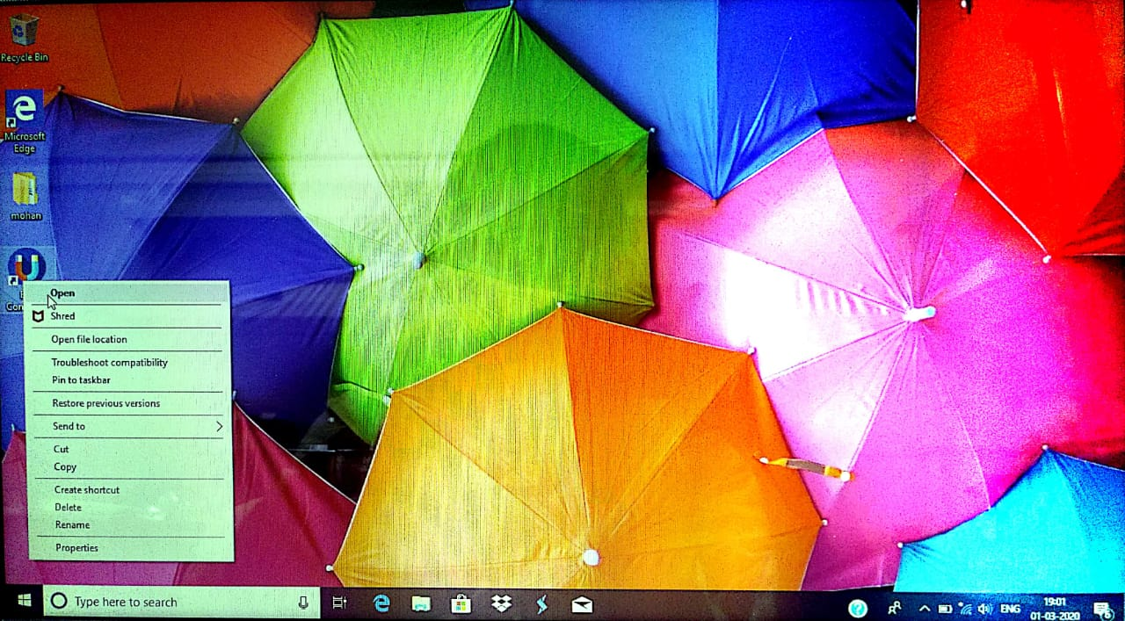Open EM controller software in LAB pc

Figure 5 Calibration

Figure 4 EM controller software in PC

* Select calibration on EM controller as shown in Figure 5 Calibration
* Click on calibrate(hysteresis calibiration) in constant current
* Click on right directed arrow, which corner right top on software
* You can observe hysteresis plot
* Wait for some time until you get process completion popup

##### CONSTANT MAGNETIC FIELD CALIBRATION

* Select calibration tab on EM controller
* Place the gauss probe is exactly middle between electromagnets
* Set a field value in constant field and click set
* Wait until it shows same magnetic field value on top (In red colour)
* Click on update in sample position and wait until successfully update box(popup)
* Place a probe at current position
* Click on update in current position and wait until successfully update box(popup)
* Click on calibrate and wait until magnetic field successfully calibrated box(popup)

##### SETTING CONSTANT MAGNETIC FIELD

* Go to measurement
* Select constant current or constant field [constant field is more precise then constant current].
* Set Ex:1000mT magnetic field and click on set

##### TURN OFF PROCEDURE

* Stop working process from pc software
* Switch off the constant current source
* Switch off the chiller pump, then chiller main

Observation:

Date: 09 Oct. 2021

Experiment Started at: 5:21 PM

Chiller Temp. set to: 8

Room temp.: 23

HEATER:

|  |  |
| --- | --- |
| Time | Temperature ($C^{0}$) |
| 5:21 pm | 127 |
| 5:52 PM | 400 |

CCPS: threshold is set ${65}^{0}C$

|  |  |
| --- | --- |
| Time | Temperature ($C^{0}$) |
| 5:48 PM | 20 |
| 5:51 PM | 25 |
| 5:53 PM | 30 |
| 5:56 PM | 35 |
| 5:58 PM | 40 |
| 6:01 PM | 45 |
| 6:04 PM | 50 |
| 6:08 PM | 55 |
| 6:11 PM | 60 |
| 6:15 PM | 65 |
| 6:16 PM | 66 (stoped) |
| 6:18 PM | 65 |
| 6:19 PM | 66 |
|  |  |
|  |  |

POLE TEMPERATURE:

|  |  |  |
| --- | --- | --- |
| Time | Temp. on left pole ($C^{0}$) | Temp. on right pole ($C^{0}$) |
| 5:48 PM | 58 | 58 |
| 5:51 PM | 57 | 57 |
| 5:53 PM | 55 | 56 |
| 5:56 PM | 54 | 55 |
| 5:58 PM | 57 | 58 |
| 6:01 PM | 56 | 58 |
| 6:04 PM | 56 | 57 |
| 6:08 PM | 55 | 57 |
| 6:11 PM | 56 | 58 |
| 6:15 PM | 57 | 58 |
| 6:18 PM | 59 | 60 |
|  |  |  |
|  |  |  |

Experiment Started at: 7:38 PM

Chiller Temp. set to: 5

Room temp.: 22.3

CCPS: threshold is set ${65}^{0}C$

|  |  |
| --- | --- |
| Time | Temperature ($C^{0}$) |
| 7:39 PM | 21 |
| 7:43 PM | 27 |
|  |  |

POLE TEMPERATURE:

|  |  |  |
| --- | --- | --- |
| Time | Temp. on left pole ($C^{0}$) | Temp. on right pole ($C^{0}$) |
| 7:39 PM | 60 | 50 |
| 7:43 PM | 59 | 50 |
|  |  |  |